Scenario
Given a data set named “Food.csv”, ABC is a leading food company that has a chain across India. It is planning to set up more franchises across the globe and wants to analyze which course food is the best seller and depending on what factors. They want to have an algorithm that can help them to start with which dishes they should add to the menu, which dishes need to be removed, and so on. We need to analyze the data using Python.
The following are the tasks that need to be performed:
- Use python script and load CSV file named “Food.csv”.
- Do missing values analysis on the preparing_time and cooking_time and fill missing value.
- Change the state and region where the value is -1 to All.
- Change the datatype of preparing_time and cooking_

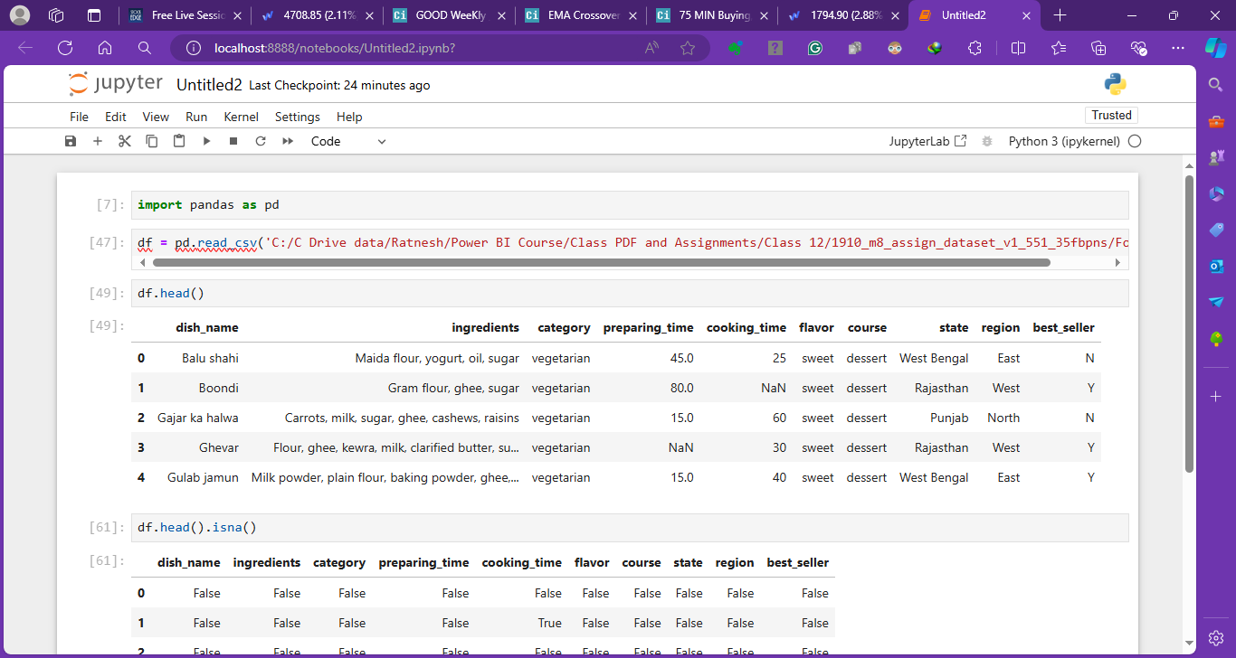
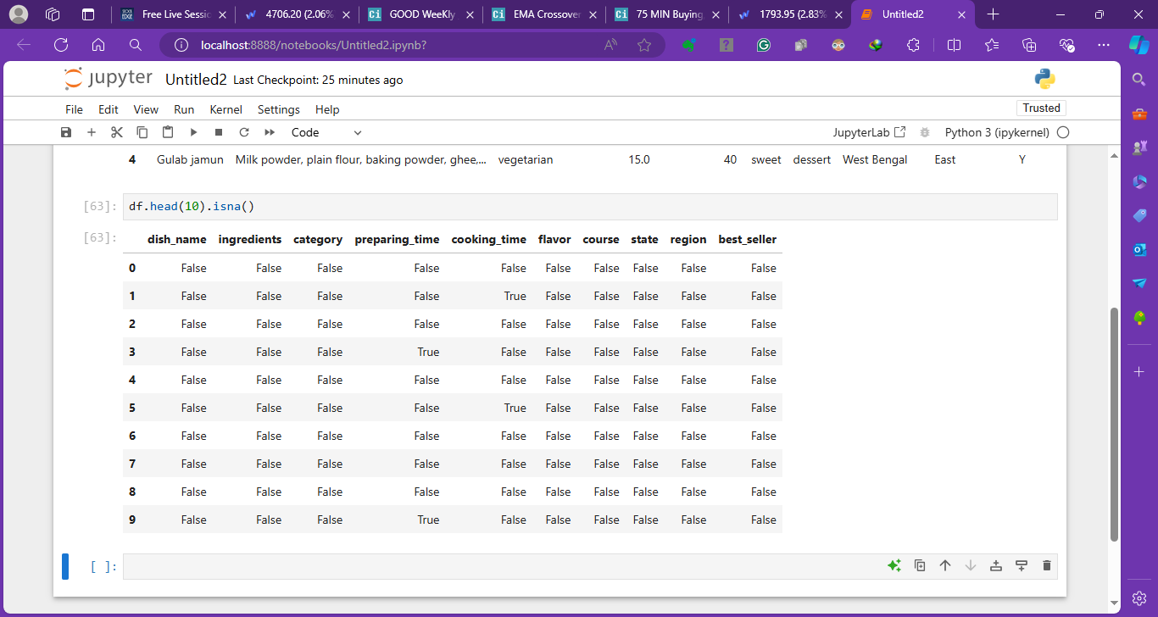
IsNULL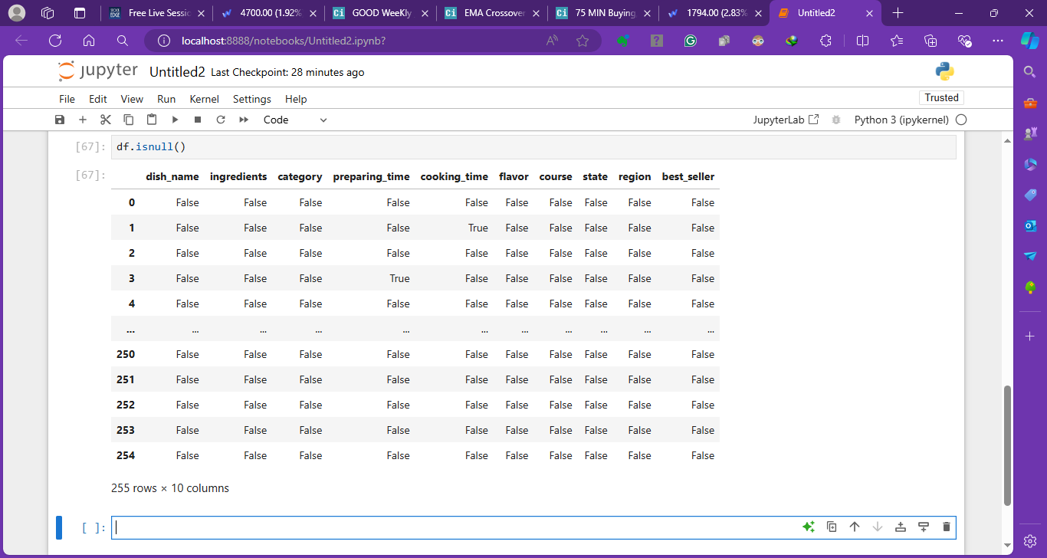
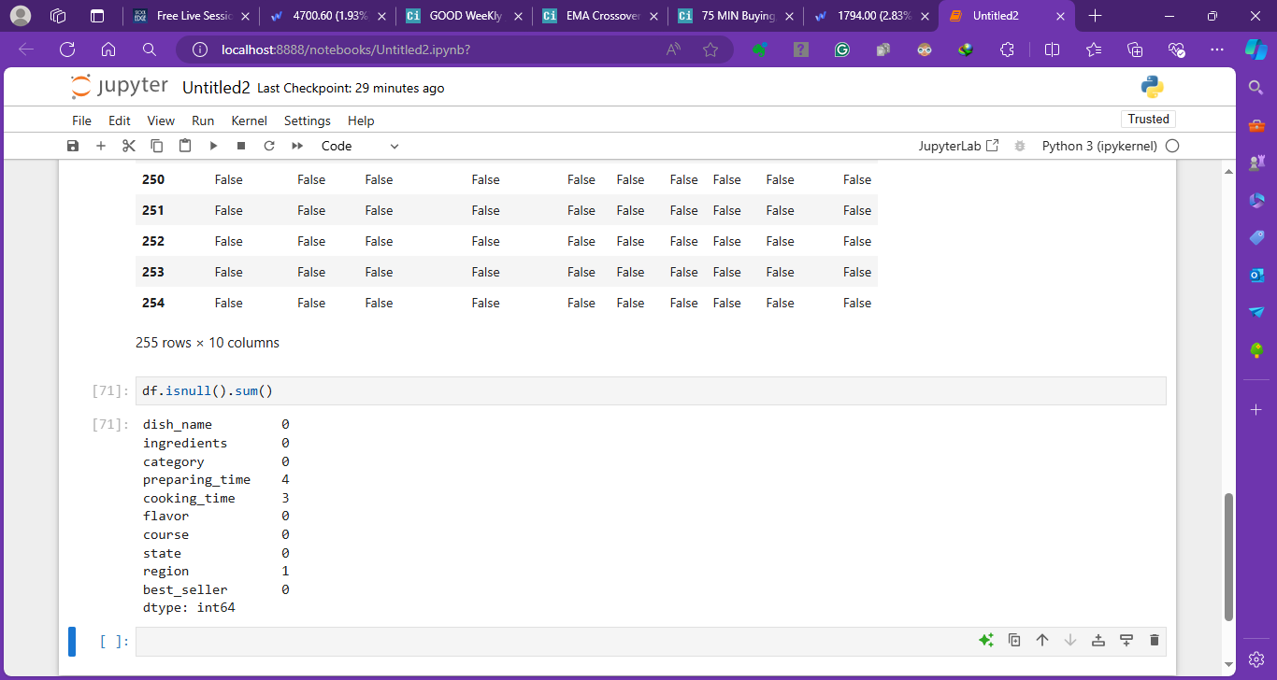
Data Types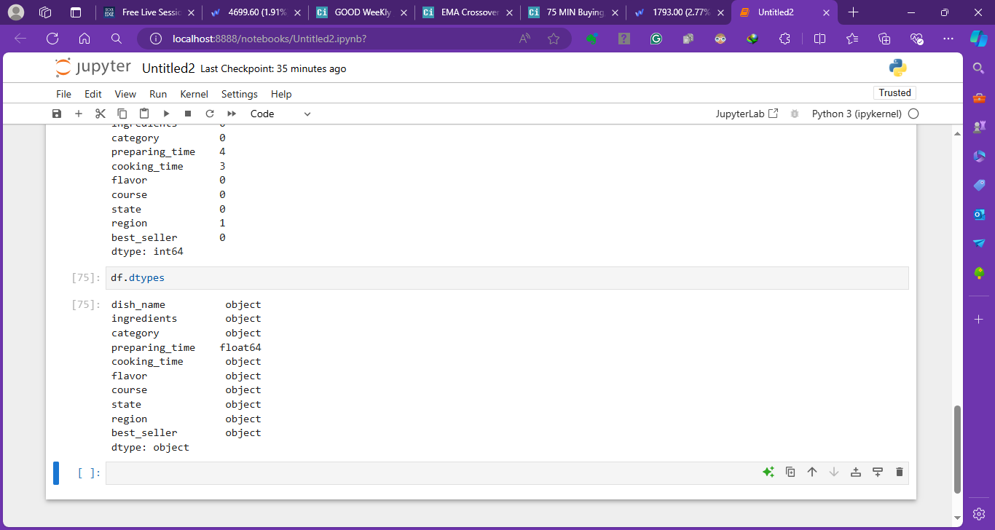
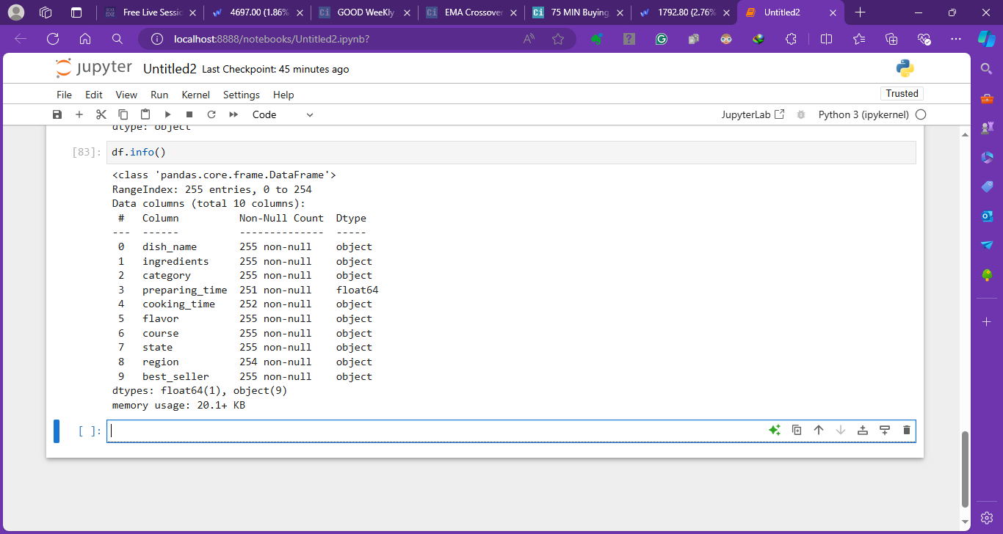
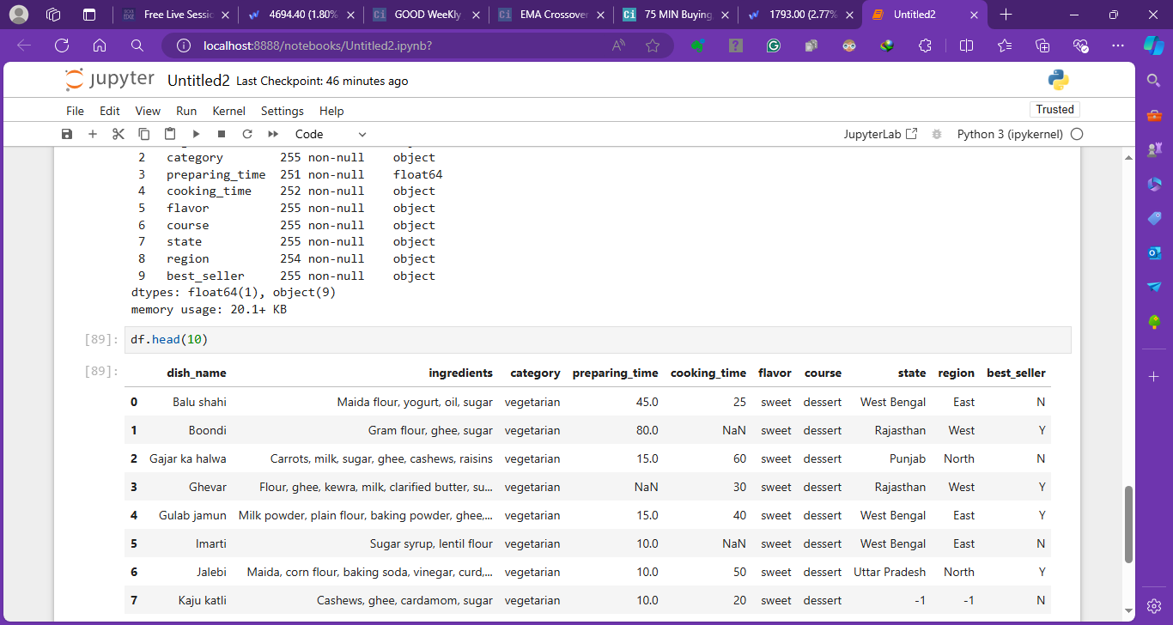
Filling null values in preparing time 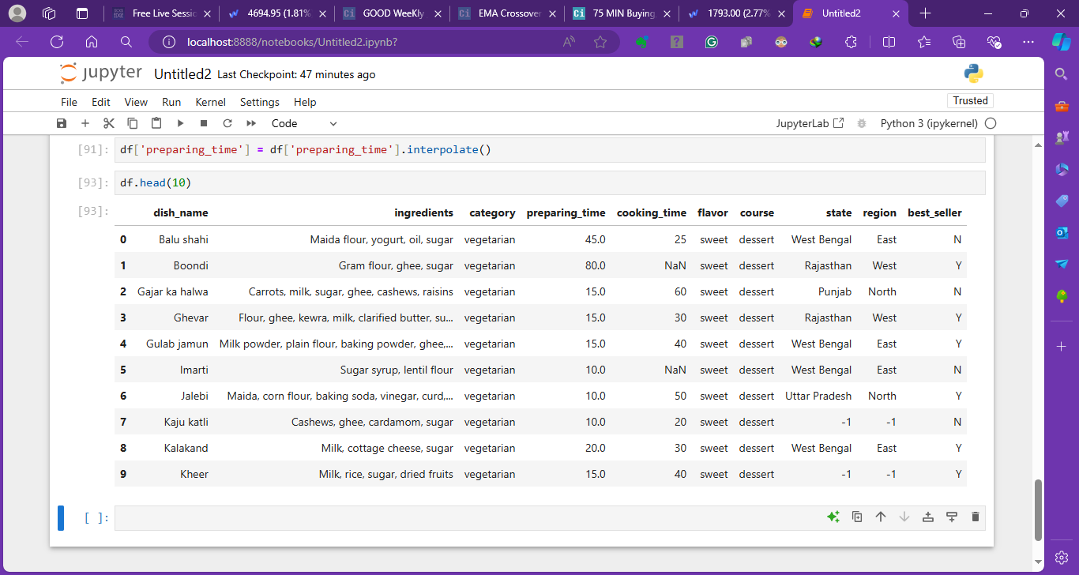
No NULL values present in preparation time column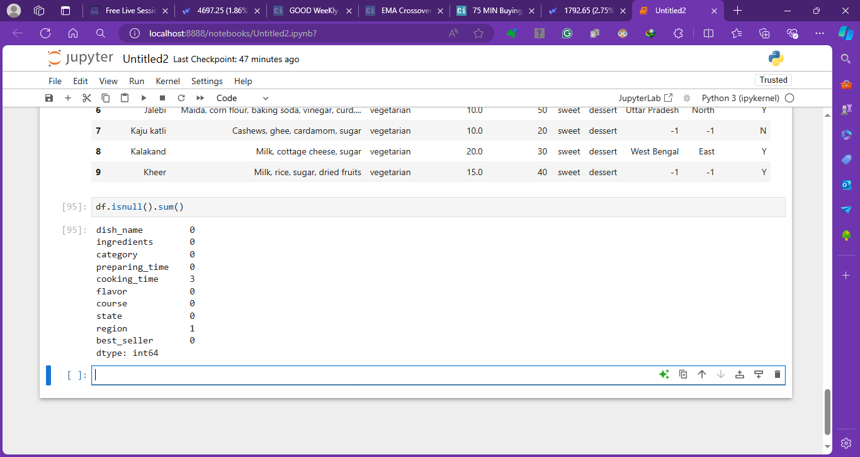
Updating cooking time from s to 0
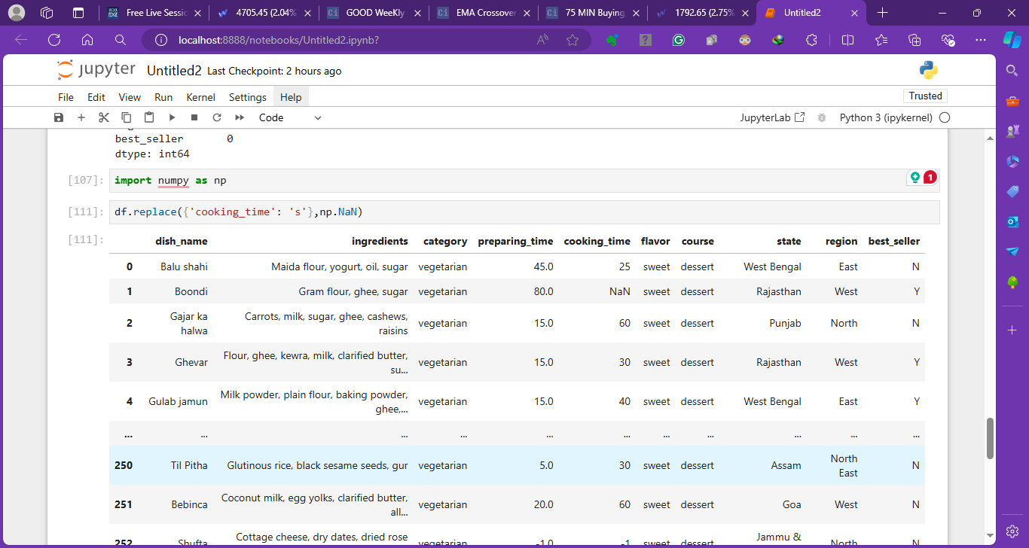
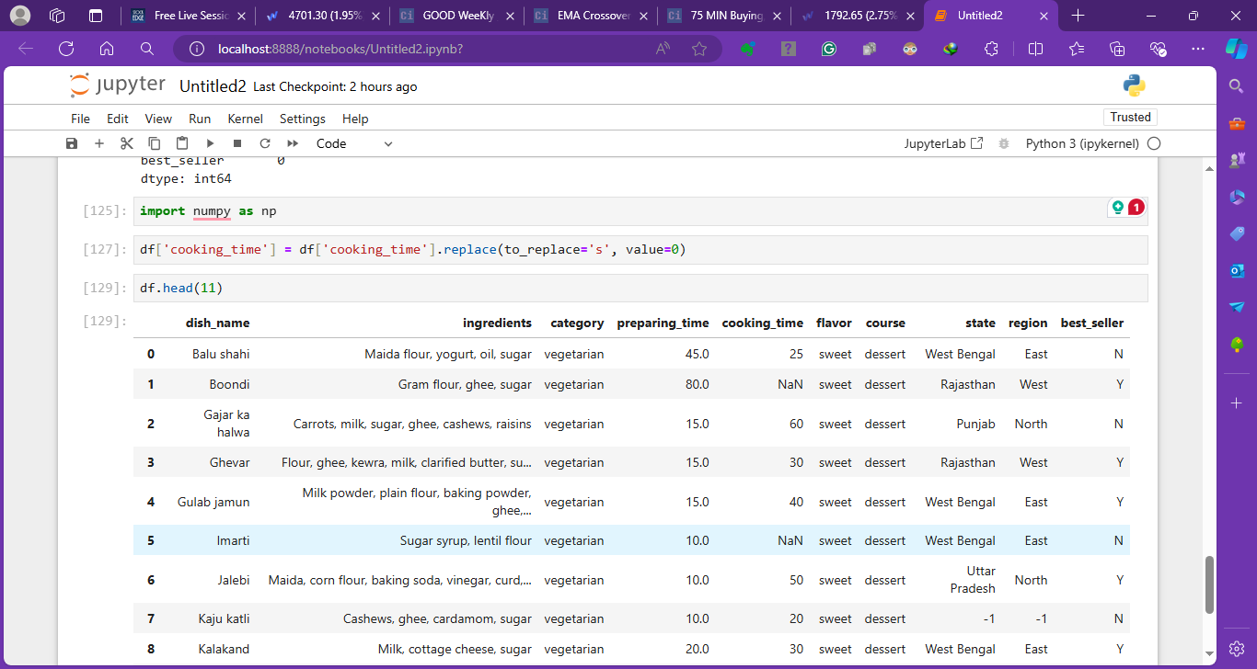
Updating from 0 to Null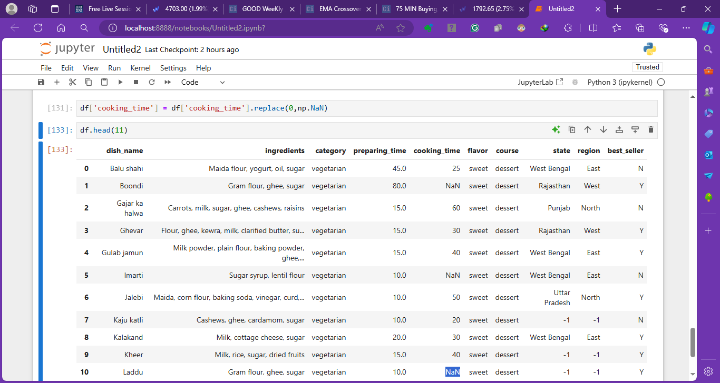
Changing the data type to Float for Cooking time 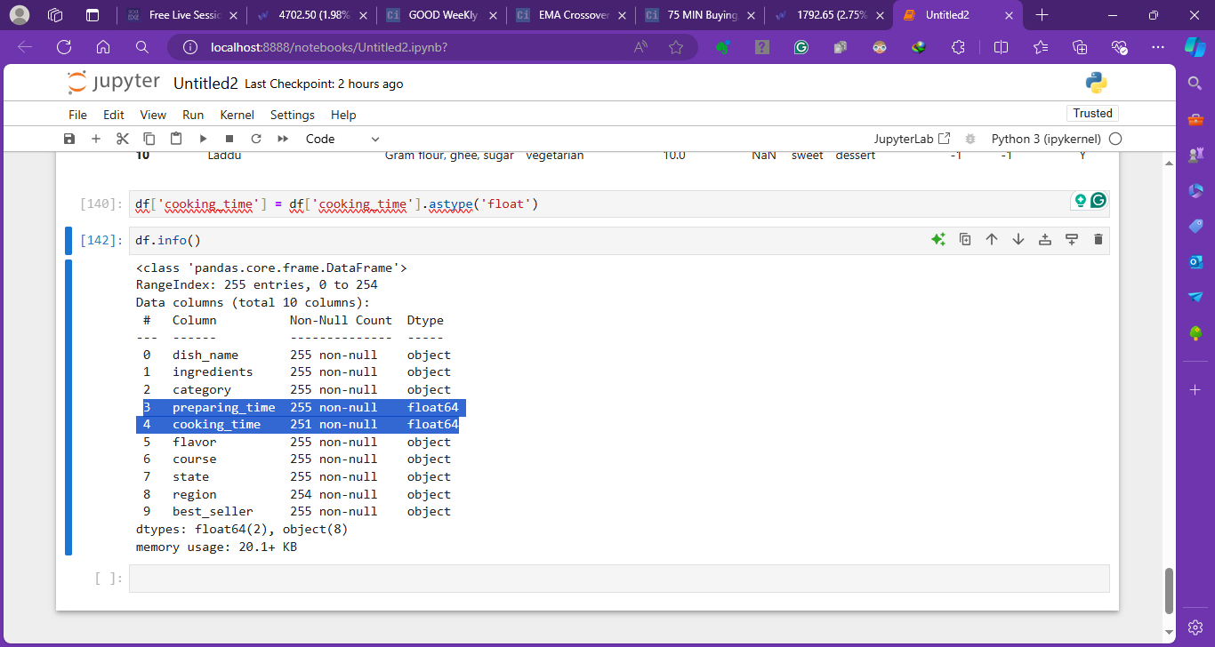
Now filling values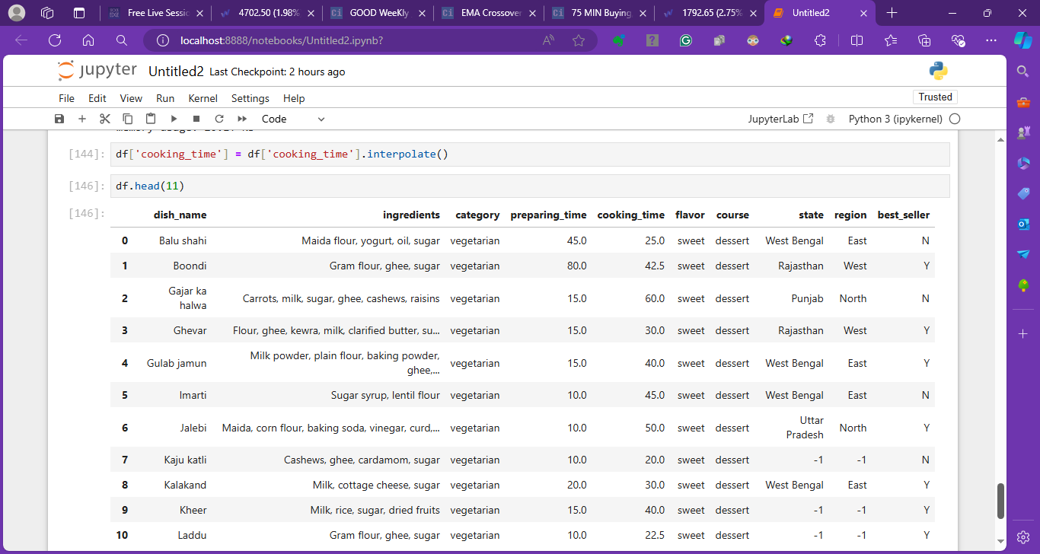
Changing the state from -1 to All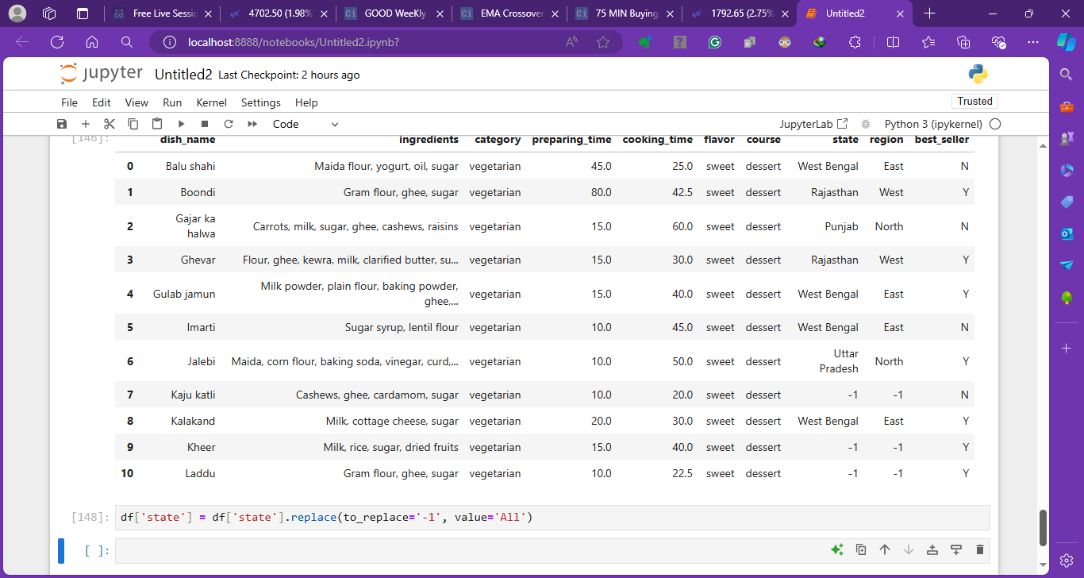
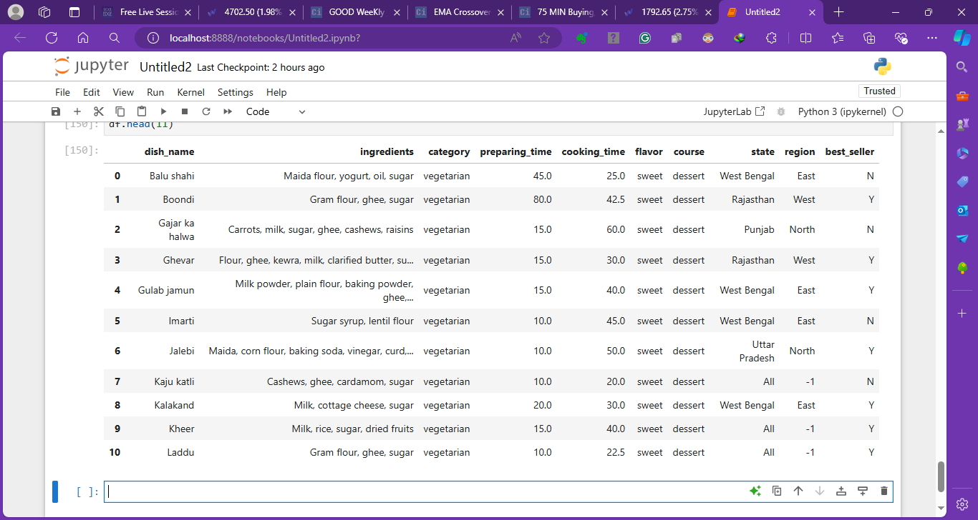
Changing Region from -1 to All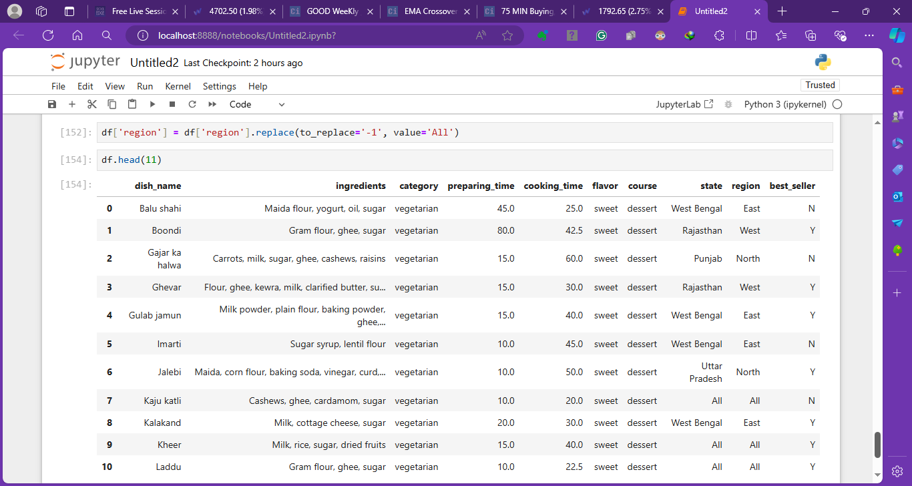
Importing file in power bi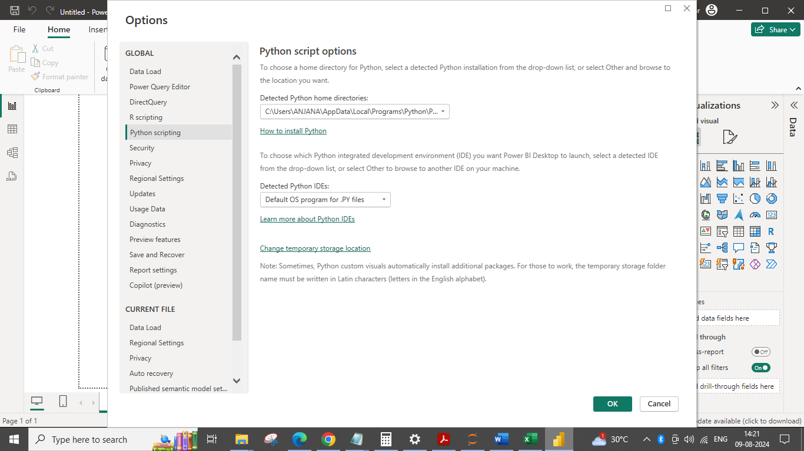
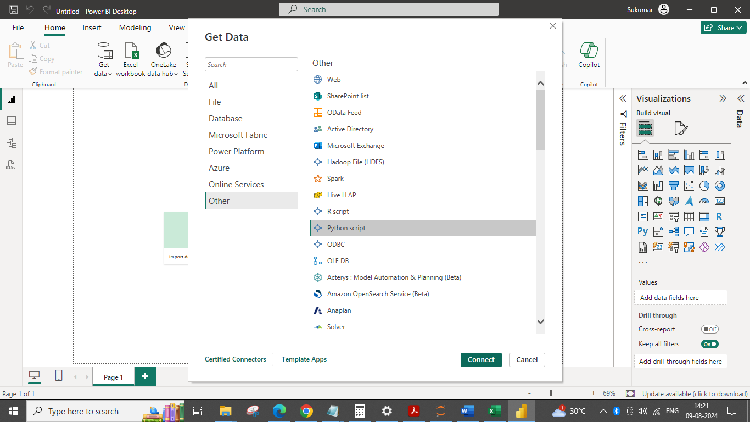
- import pandas as pd
- import numpy as np
- df = pd.read_csv('C:/C Drive data/Ratnesh/Power BI Course/Class PDF and Assignments/Class 12/1910_m8_assign_dataset_v1_551_35fbpns/Food.csv')
- df['preparing_time'] = df['preparing_time'].interpolate()
- df['cooking_time'] = df['cooking_time'].replace(to_replace='s', value=0)
- df['cooking_time'] = df['cooking_time'].replace(0,np.NaN)
- df['cooking_time'] = df['cooking_time'].astype('float')
- df['cooking_time'] = df['cooking_time'].interpolate()
- df['state'] = df['state'].replace(to_replace='-1', value='All')
- df['region'] = df['region'].replace(to_replace='-1', value='All')
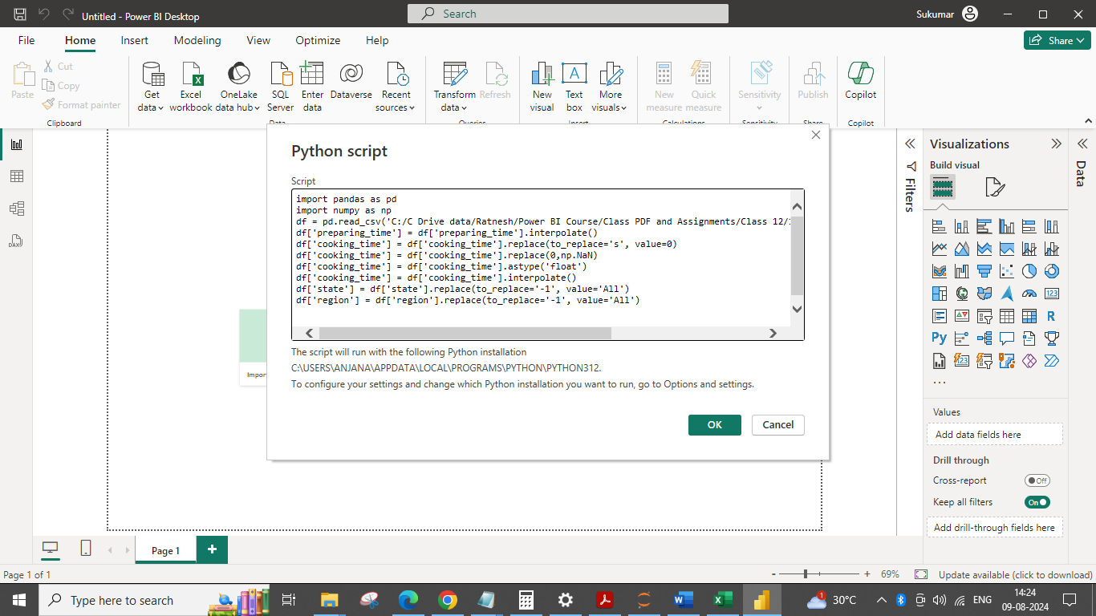
After changing NaN to nan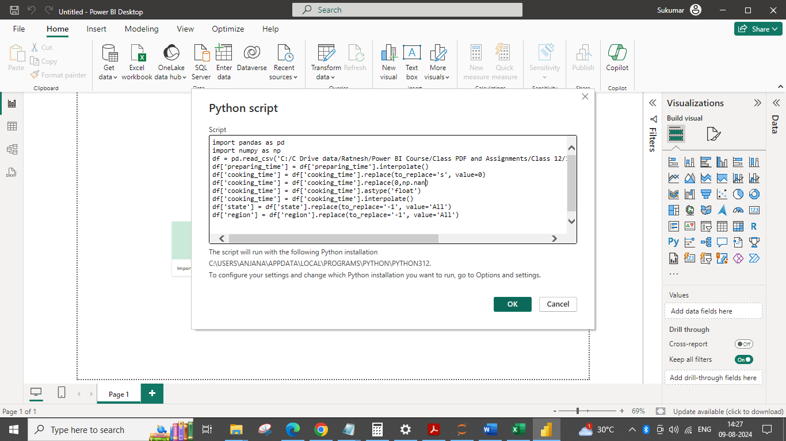
Loading Data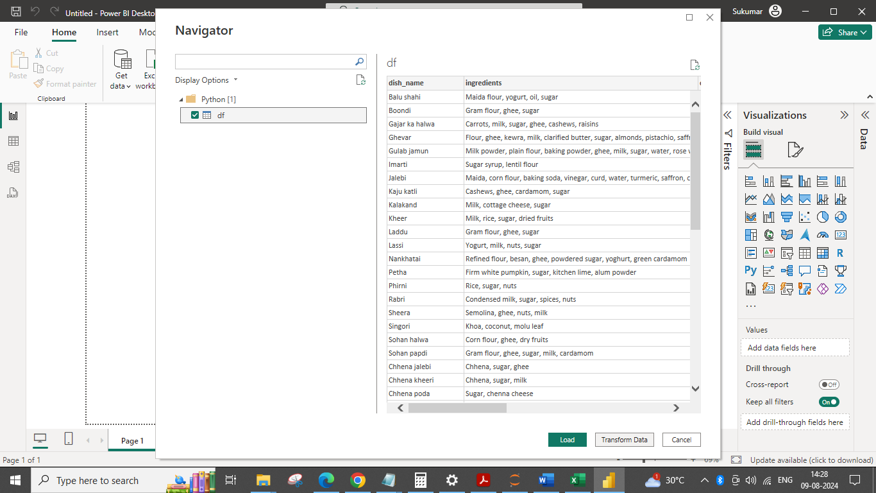
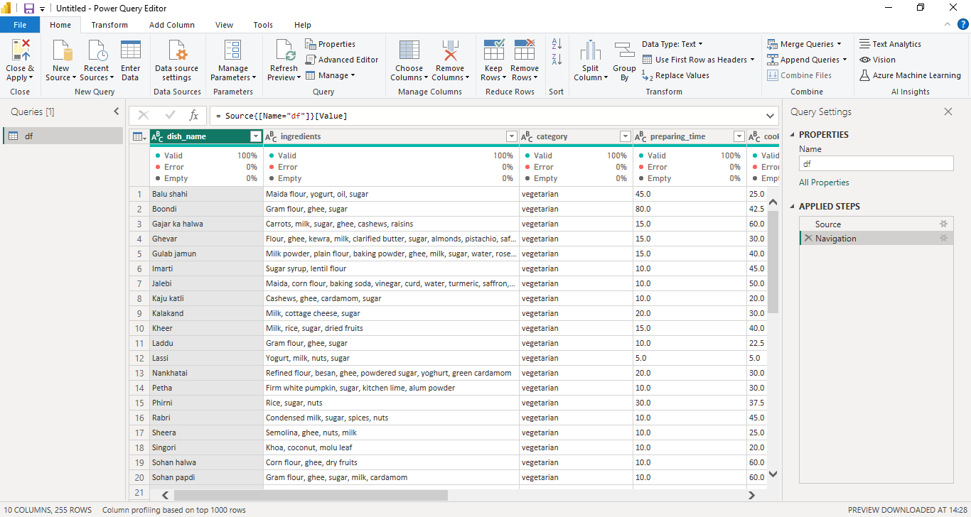

Changing the data type from text to numeric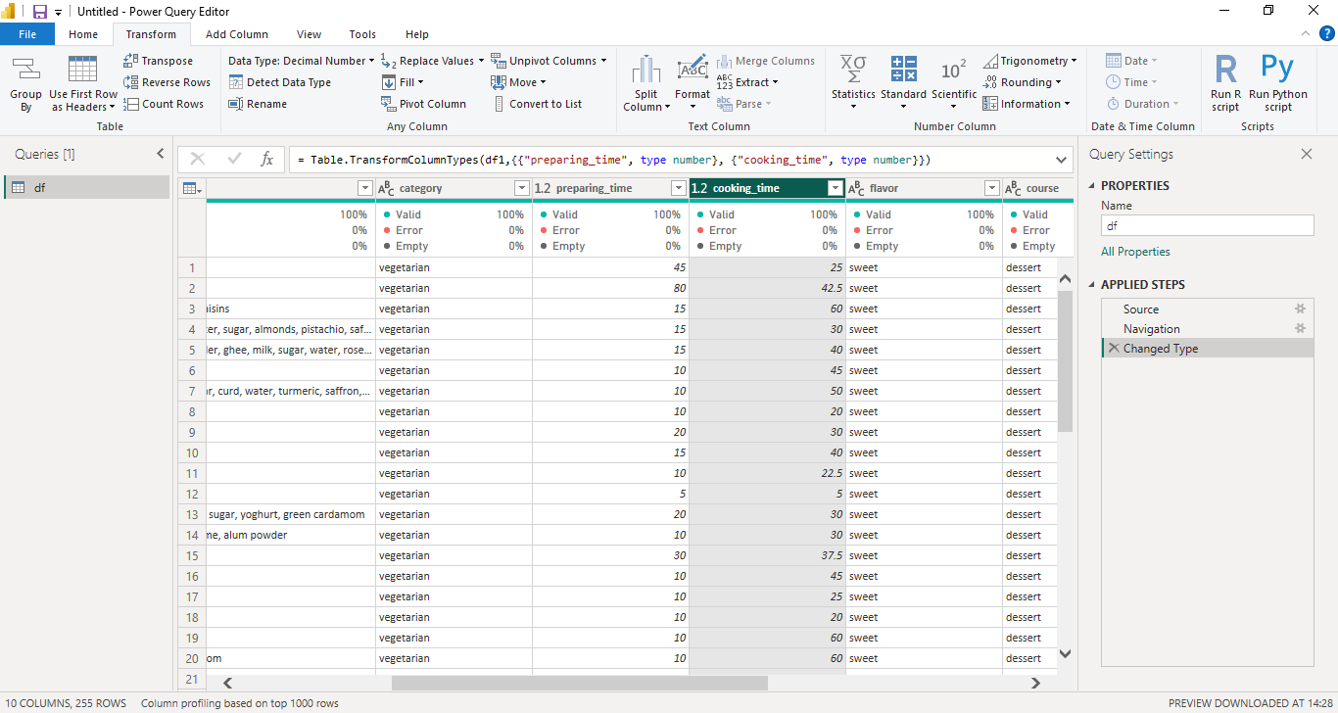

3. Create a new column based on ingredients and name it “Contains Sugar”.
Hint: Mark it Yes if the ingredient column has sugar as one of the ingredients or No if it doesn’t.
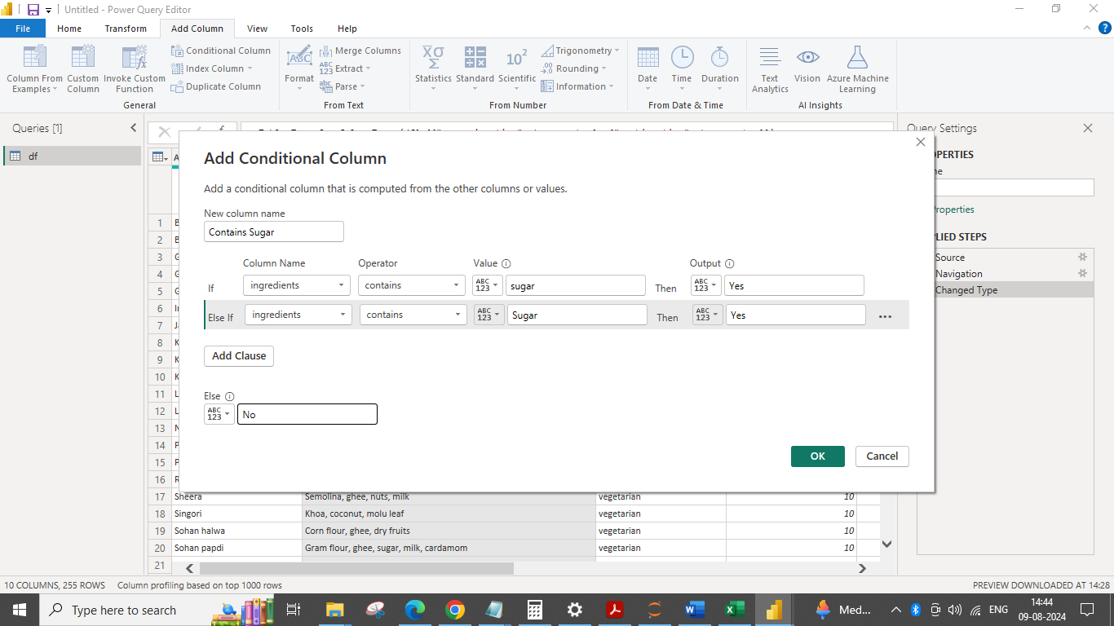
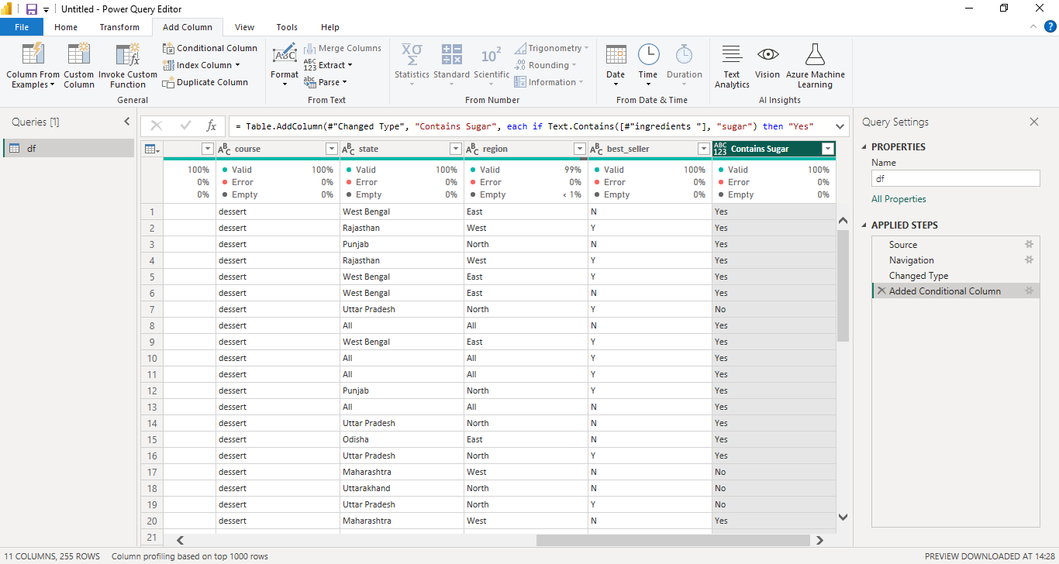
4. Print state-wise best seller dishes in the main course group by category. Ignore the states where values are “All”.
5. List all the sweets which take more than 35 min of cooking time.
  - 6. Rename the category column to Food Choice.
  - a. Change the values vegetarian to veg and non-vegetarian to non-veg.
  - 
   